**Key Word Wheel**

AQA Science ISA

P.J.McCormack

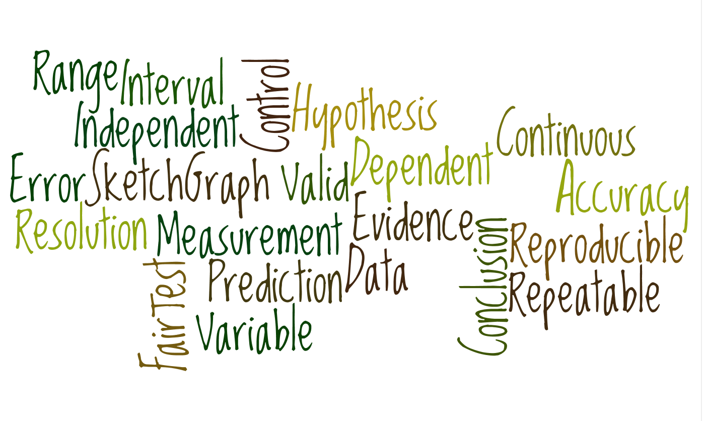

Cut out here



Cut out here

Cut on the outside of blue line.

Place this circle underneath the other one and

fasten in the middle with a split pin.



A test in which only the independent variable is allowed to affect the dependent variable.

Data which has been shown to be valid

Information that is collected.

A proposal intended to explain facts or observations.

Values that do not fit the pattern of results

Measurements that are very close to each other.

The variable that is measured.

If another person repeats the experiment and gets the same results

A line graph that shows the general pattern of the results.

The maximum and minimum values e.g. 10 cm to 50 cm.

The difference between the measured value ad the true value.

The value that is produced in an ideal measurement.

A conclusion supported by data.

The difference between measurements.

Variables that can have any numerical value.

Variable that is kept the same in the experiment.

Errors caused by factors we can’t control.

A suggestion of what happen in an experiment.

The suitability of an investigation to answer a question.

The smallest measurement that can be made with the measuring instrument.

The variable that is changed by the investigator.

If the same person repeats the experiment and gets the same results

A measurement that is close to the true value.

**Key Word Wheel**

**True Value**

**Anomalies**

**Accuracy**

**Dependent Variable**

**Range**

**Measurement Error**

**Valid Conclusion**

**Fair Test**

**Interval**

**Continuous Variable**

**Control Variable**

**Repeatable**

**Random Error**

**Prediction**

**Validity**

**Sketch Graph**

**Reproducible**

**Precision**

**Data**

**Evidence**

**Hypothesis**

**Resolution**

**Independent Variable**